PROGRAMMING ASSIGNMENT

3D COMPUTER GRAPHICS AND ANIMATION



Group Members:

Fadel Cahyo M. (001201700040)

Faisal Abdul Rafi (001201700035)

Septian Calvin Infa W. (001201700055)

1. **Introduction**

This program display that simulate the shading of a 3D cube. The user can be able to rotate the cube around the x, y, and z axis, translate the cube on the x,y,and z axis, perform back face culling on the cube, and illuminate the cube using flat shading. Include ambient light and diffuse lighting. And the user allow to change the diffuse and ambient coefficient of the cube. The last is, the user can move the light source to another location.

This programming assignment use Visual Basic as a programming language to build this application.

1. **Basic Theory**
   1. Lighting / Illumination and Shading.

The lighting model is called the lighting model and is sometimes referred to as the shading model, used to calculate the intensity of light that we have to see at a certain point on the surface of an object. The illumination model is also to determine the color of the surface point by simulating several light attributes.

A surface rendering algorithm uses the intensity calculations from an illumination model to determine the light intensity for all projected pixel positions for the various surfaces in a scene. Surface rendering can be performed by applying the illumination model to every visible surface point. When light occurs on an opaque surface, part of it is reflected and partly absorbed. The amount of light reflected by a surface depends on the type of material from the surface itself.

Surfaces that are rough, or grainy, tend to scatter the reflected light in all directions. This scattered light is called diffuse reflection. In addition to diffuse reflection, light sources create highlights, or bright spots, called specular reflection.

* 1. Ambient, Diffuse, and Specular Lights
* 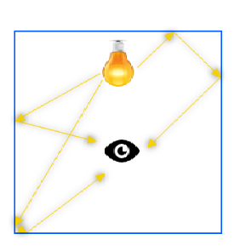Ambient light is the light that enters a room and bounces multiple times around the room before lighting an object. The amount of ambient light depends on the light’s ambient color and the ambient material color.

From the picture above, and according to the explanation above that the light that has left its source and the light bounces to many surfaces before reaching the eye. The eye receives approximately the amount the same light from all directions. Provides lighting that is even "ambient" for all walls.

Ambient light is considered constant in lighting model. There is ambient reflection influenced by the ambient intensity of objects. Therefore there is a formula for calculating the amount of ambient light.

$I_{AMB}= I_{A} . K_{A}$

$$I_{A}=Ambient color of the object$$

$$K_{A}=Ambient intesity of object$$

From the formula above the value of $K_{A}$ constant, therefore ambient light is considered constant in lighting model.

* 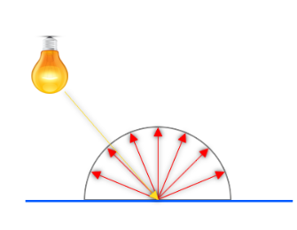Diffuse light represents direct light hitting a surface. The Diffuse Light intensity is dependent on the reflection angle. For example, light hitting a surface at a 90-degree angle contributes more than light hitting the same surface at 5 degrees.

When light comes directly from a source and hits a rough surface, it is scattered in all directions away from the surface. Any viewers within 180° of the reflected hemisphere will see roughly the same color being reflected from the surface. In the illumination model, the light is scattered equally in all directions.

* 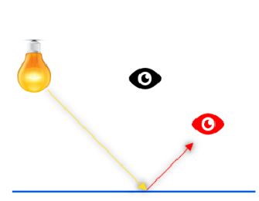Specular light is the white highlight reflection seen on smooth, shiny objects. Specular light is dependent on the direction of the light, the surface normal and the viewer location. Specular light is reflected almost perfectly by the surface with no scattering.

From the picture above, the yellow light emitted to the surface perfectly because of the smooth surface. where red eyes here will see the light reflection from the reflection of a smooth surface. and the black eyes here will barely see the light reflected by the yellow rays that emanate because the light shines on a smooth surface with no scattering

* 1. Phong Illumination Model

The Phong model assumes that the intensity of each pixel is the sum of the intensity due to diffuse, specular, and ambient lighting. This model takes into account the location of a viewer to determine specular light using the angle of light reflecting off an object.

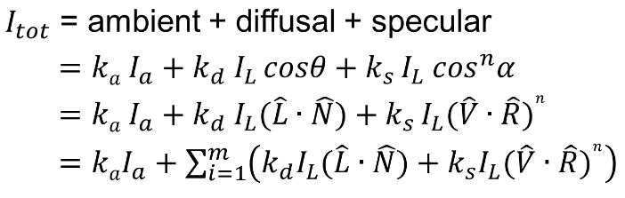

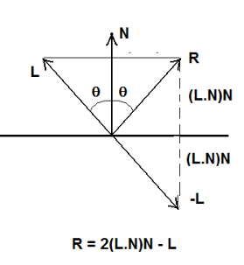From the picture above. Because the ambient light is constant, cosine angle here is very influential. This calculation is affected by the value of the location of the light source, each surface, and the location of the viewer. $\hat{R}$ value arises because of the consequences of light reflection given by the light source.

From the picture above, the $\hat{R}$ value is affected by the vector of N and L.

* 1. Flat Shading

Flat shading is the simplest shade model that calculates illumination at one point for each polygon which means that it produces the same value for all pixels in the whole polygon.

Flat shading is a normal lighting technique and the direction of the light source, their respective colors and the intensity of the light source. This is usually used for high-speed rendering where each and every polygon in a flat shade is drawn in the same color and the normal for all polygons must be known. Color flattens quickly because the lighting equation is used once per polygon.

1. **Implementation**
   1. Main interface and Component of Interface

This program is a GUI-based application that uses windows form, so it has an interactive display. Because of using windows form, this application can only be used on Windows operating system. The interface of the program is shown below:

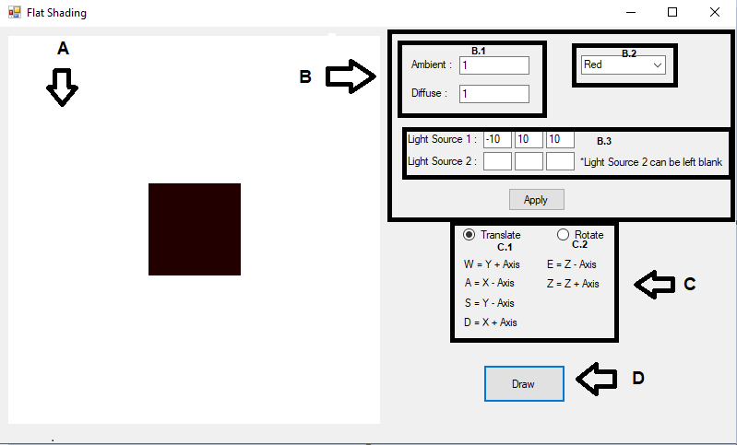

* 1. Program Component

The program interface is shown above consists of several components that are listed below:

1. Picturebox

The Picture Box is used to display the cube.

1. Set Value Group Box

This Group Box is used to provide the following buttons and textboxes :

B.1

* TextBox Ambient

TextBox Ambient is used to input the ambient value of the light.

* TextBox Diffuse

TextBox Diffuse is used to input the diffuse value of the light.

B.2

* Combo Box Set Color

Combo Box set Color is used to choose the color of the light.

B.3

* TextBox Light Source 1 X

TextBox Light Source 1 X is used to input the X value of the light source 1.

* TextBox Light Source 1 Y

TextBox Light Source 1 Y is used to input the Y value of the light source 1.

* TextBox Light Source 1 Z

TextBox Light Source 1 Z is used to input the Z value of the light source 1.

* TextBox Light Source 2 X

TextBox Light Source 2 X is used to input the X value of the light source 2.

* TextBox Light Source 2 Y

TextBox Light Source 2 Y is used to input the Y value of the light source 2.

* TextBox Light Source 2 Z

TextBox Light Source 2 Z is used to input the 2 value of the light source 2.

B.4

* Button Apply

Button Apply is used to execute all the proccess in the B GroupBox.

1. Command Group Box

This Group Box is used to provide the following buttons :

* Translate Radio Button

Translate Radio Button is used to set translate action for the cube.

* Rotate Radio Button

Rotate Radio Button is used to set rotate action for the cube.

1. Button Draw

Button Draw is used to draw the cube.

* 1. Program Features

1. Display a Cube

This program’s main feature is displaying a cube using list of surfaces. When the draw button is clicked, the cube will be shown in the picture box.

1. Set Value

B.1. Change Ambient and Diffuse Value

This program is also allowing the user to change the Ambient and Diffuse value of the light source.

B.2. Change Color of The Illumination

This program is also allowing the user to change the color of the light source.

B.3. Change the Light Source Value

This program is also allowing the value of the light source.

1. Translating and Rotating

C.1 Translating the Cube

The cube in this program is able to be translated in all axis. The user is possible to type the command translation depending on key user type, the cube will be translated.

C.2 Rotating the Cube

The cube in this program is able to be rotated in all axis. The user is possible to type the command rotate depending on key user type, the cube will be rotated.

1. **Design**
   1. Main data structure

Structure Vector

Public i, j, k As Single

End Structure

Structure Edge

Dim point1, point2 As Integer

End Structure

Structure Vertex

Dim x, y, z, w As Single

End Structure

* 1. Main/ global variable

Dim vertices(10) As Vertex

This variable is use to store the value of vertices.

Dim edges(11) As Edge

This variable is use to store the value of the edge.

Dim surfaces(5) As Surface

This variable is use to store the value of the surface.

Dim pr(3, 3) As Single

This variable is use to store matrix value of pr.

Dim Translate(3, 3) As Single

This variable is use to store matrix value of Translate.

Dim Rotatex(3, 3) As Single

This variable is use to store matrix value of RotateX.

Dim Rotatey(3, 3) As Single

This variable is use to store matrix value of RotateY.

Dim Rotatez(3, 3) As Single

This variable is use to store matrix value of RotateZ.

Dim view(3, 3) As Single

This variable is use to store matrix value of view.

Dim screen(3, 3) As Single

This variable is use to store matrix value of screen.

Dim dx As Single

This variable is use to move the cube along X axis.

Dim dy As Single

This variable is use to move the cube along Y axis.

Dim dz As Single

This variable is use to move the cube along Z axis.

Dim VS(15) As Vertex

This variable is use to store view screen value.

Dim VR(15) As Vertex

This variable is use to store view screen value.

Dim VW(15) As Vertex

This variable is use to store view screen value.

Dim ka As Single

This variable is use to store ka value.

Dim kd As Single

This variable is use to store kd value.

Dim Ia As Vector

This variable is use to store Ia value..

Dim IL As Vector

This variable is use to store IL value. .

Dim Iamb As Vector

This variable is use to store Iamb value. .

Dim Idif As Vector

This variable is use to store Idif value..

Dim Itot As Vector

This variable is use to store Itot value.

1. **Evaluation**

In this evaluation, the program can evaluate following cases, such as moving cube along each axis, rotating cube along each axis, moving the light source along each axis, and changing the values of the ambient and diffuse coeficients. The default position of the program as the picture shown below.

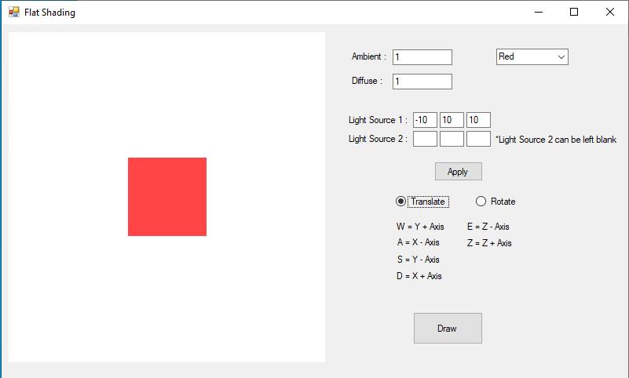

5.1 Moving The Cube Along Each Axis

The Cube can move in the x, y, and z axis. The test case shown below :

* 1. Moving on X Axis

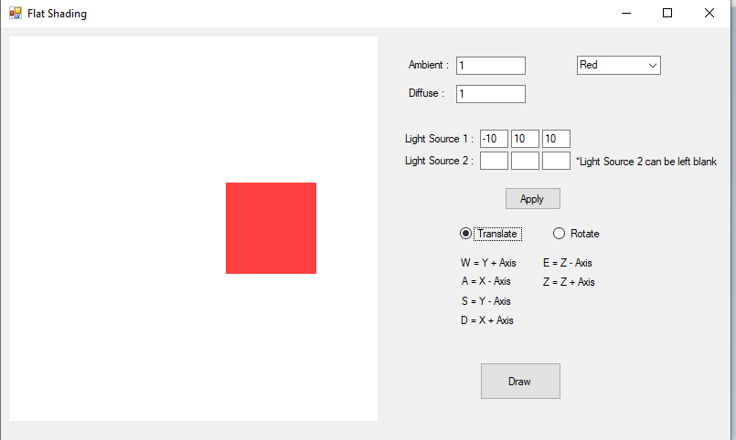

The Cube move from center to the right side, because user click the D command

This program successfully moving the sphere on the X axis without any errors

* 1. Moving on Y Axis

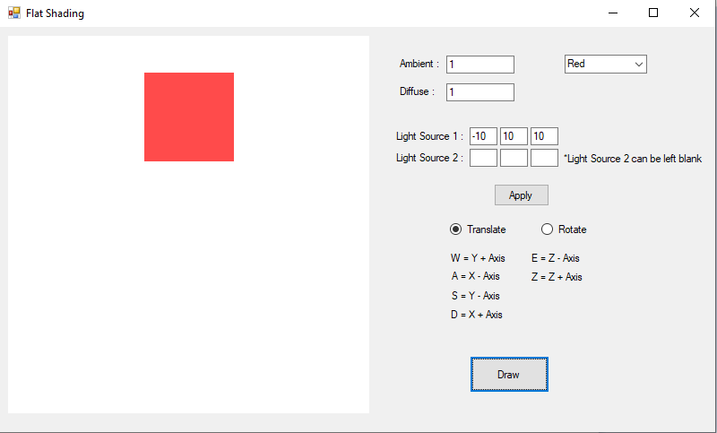

The Cube move from center to the right side, because user click the W command

This program successfully moving the sphere on the Y axis without any errors

* 1. Moving on Z Axis

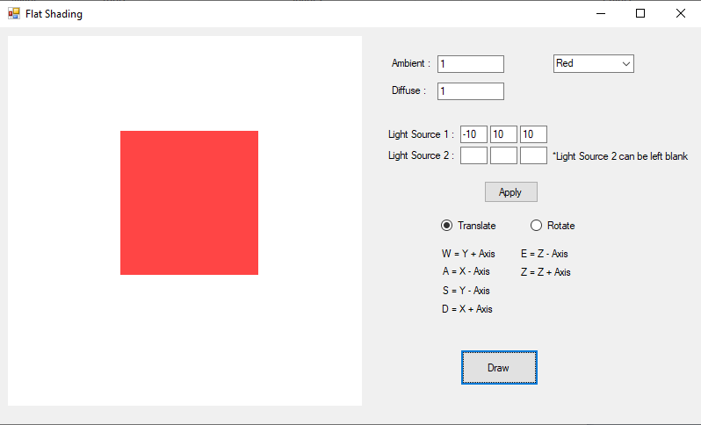

The Cube change to bigger size, because user click the Z command

This program successfully moving the sphere on the Z axis without any error

5.2 Rotating the Sphere Along Each Axis

1. Rotating on X Axis

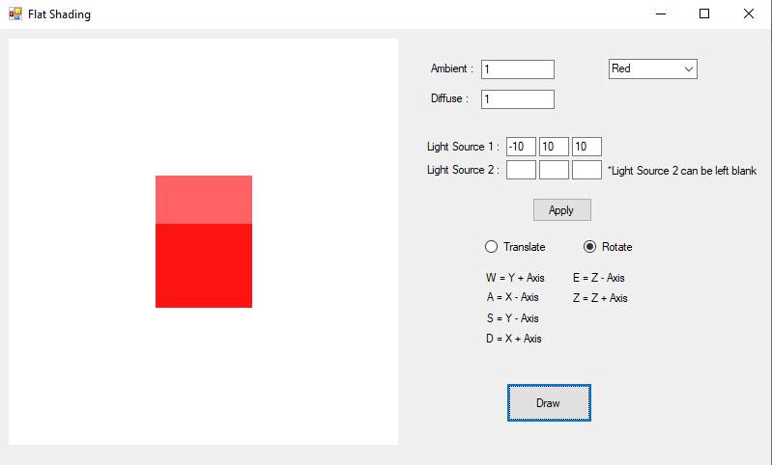

The Cube rotating on X axis from default position.

This program successfully rotating the cube on the X axis without any errors.

1. Rotating on Y Axis

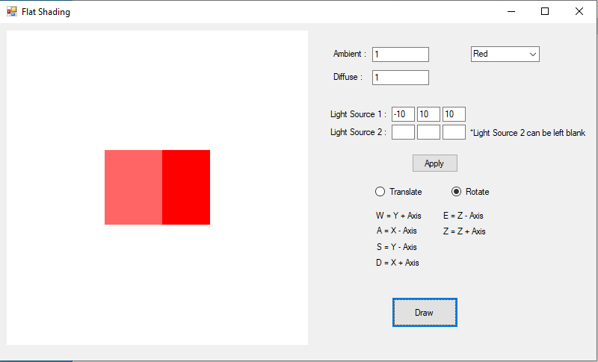

The Cube rotating on Y axis from default position.

This program successfully rotating the cube on the Y axis without any errors.

1. Rotating on Z Axis

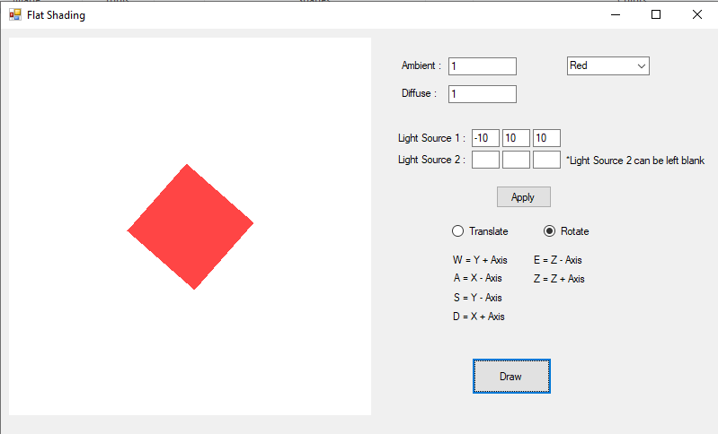

The Cube rotating on Z axis from default position.

This program successfully rotating the cube on the Z axis without any errors.

5.3 Changing the Light Source along Each Axis

* 1. Changing the Light Source on X Axis

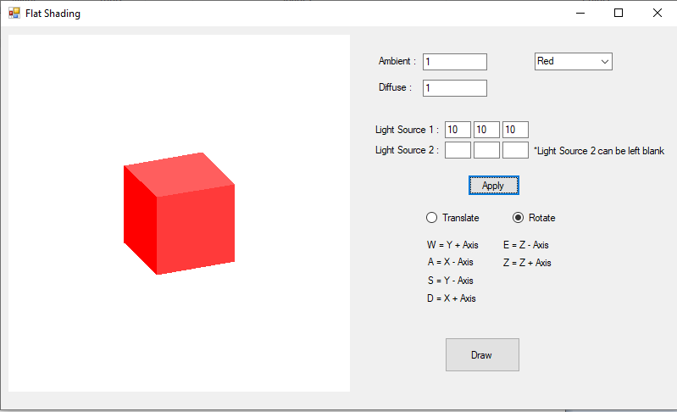

The Light Source on X Axis change from -10 to 10

This program successfully change the light source on the X axis without any errors.

* 1. Changing the Light Source on Y Axis

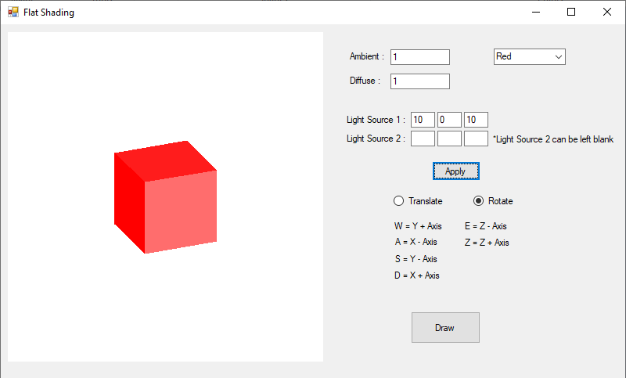

The Light Source on Y Axis change from 10 to 0

This program successfully change the light source on the Y axis without any errors.

* 1. Changing the Light Source on Z Axis

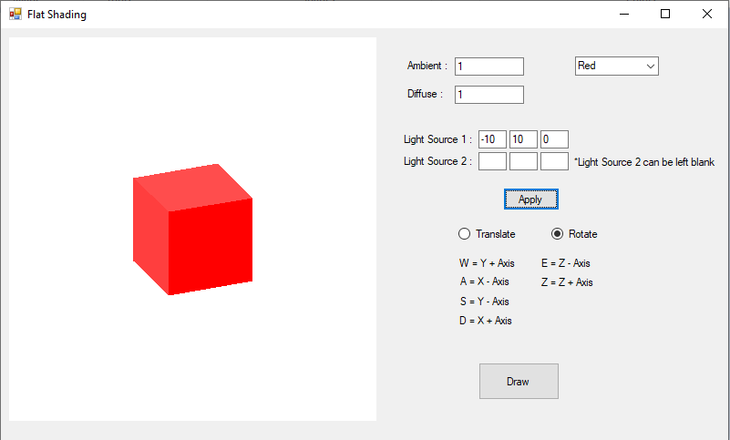

The Light Source on Z Axis change from 10 to 0

This program successfully change the light source on the Z axis without any errors.

5.4 Changing the Value of Ambient and Diffuse Coeficient

1. Change the Value of Ambient

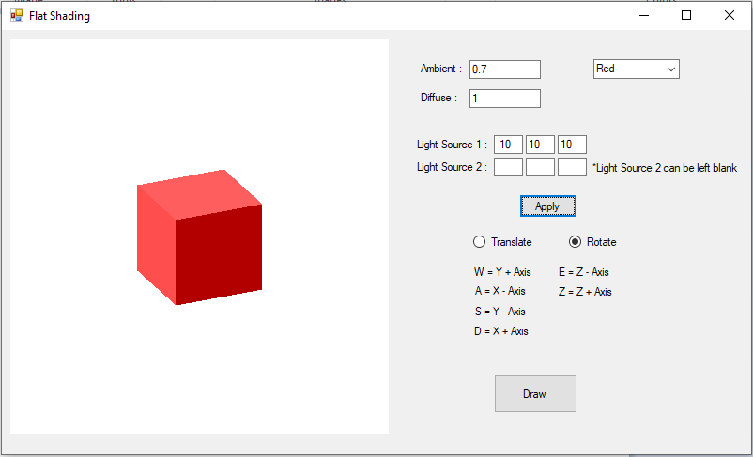

This program can change the ambient value from 1 to 0,7

This program successfully changing the value of Ambient without any errors

1. Change the Value of Diffuse

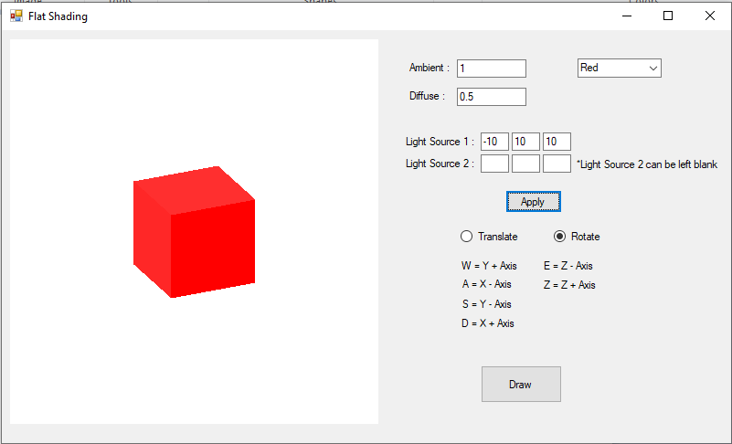

This program can change the diffuse value from 1 to 0,5

This program successfully changing the value of Diffuse without any errors

1. **Work Log**

**Summary**

* **Rotate the cube around the x, y, and z axes. The users can rotate the cube around x, y, and z axes and it is fully implemented.**
* **Translate the cube on the x, y, and z axes. The users can translate the cube on x, y is fully implemented.**
* **Perform back face culling on the cube. The users can perform back face culling, it is fully implemented.**
* **Illuminate the cube using flat shading. Include ambient and diffuse lighting. This is fully implemented.**
* **Allow the user to change the diffuse and ambient coeficient of the cube. It is fully implemented.**
* **Move the light source to another location. It is fully implemented.**

|  |  |  |
| --- | --- | --- |
| **Date** | **Progress** | **Personal Involved** |
| **11 November 2019** | **Got Programming Assignment** | Fadel, Faisal, Septian |
| **12 November 2019** | Decide to use Visual Basic Programming Language | Fadel, Faisal, Septian |
| **14 November 2019** | Make User Interface | Fadel, Faisal |
| **16 November 2019** | **Can rotate the cube around x, y, and z axes** | **Septian, Fadel** |
| **18 November 2019** | **Can translate the cube on the x, y, and z axes** | **Septian, Fadel** |
| **21 November 2019** | **Perform back face culling on the cube.** | **Septian, Fadel** |
| **25 November 2019** | **Can Illuminate the cube using flat shading. Include ambient and diffuse lighting.** | **Septian** |
| **27 November 2019** | **Allow the user to change the diffuse and ambient coeficient of the cube.** | **Septian** |
| **30 November 2019** | **Move the light source to another location. And Make a Report** | **Septian, Faisal** |
| **1 December 2019** | **Add another light source.** | **Septian** |
| **2 December 2019** | **Submit The Programming Assignment** | Fadel, Faisal, Septian |

1. **Conclusion and Remarks**

The programs is already completed, the program can rotate the cube, translate the cube on all axis and translate on all axis. And perform back face culling. The program can illuminate the cube using flat shading. The user can allow to change the diffuse and ambient coefficient of the cube and move the light source to another location.

In this programming assignment we learn about the material more depth especially about illumination and flat shading. We need to know more details to make the report and how explain the materials. Also this programming assignment is challenging us.